Final Project Report

# Project Overview:

AI train itself on how to play the game of Flappy Bird. By assign inputs value for the NEAT algorithm. And after many generations of slowly learning and getting better. Finally, its picks up on patterns and figures out how to progress further until game over. This uses something called a genetic algorithm and the exact genetic algorithm we use is called NEAT now that stands for neuro evolution of augmenting topologies.

Essentially after a few generations the AI starts to get exponentially better until eventually reaches a point where it can't be lost, and it can conquer the game without hitting the pipe.

# Requirements:

* Create an application using knowledge study in machine learning course

# Basis knowledge

* Genetic Algorithm
* Neuron Network
* Neuro Evolution of Augmenting Topologies (NEAT)

# Objectives:

* Create a program that can play Flappy Bird automatically using NEAT algorithm

# Record your notes/research here:

**What are Neural Networks?**

Neural networks come in what we call layers, and the first layer is input layer.

The input layer is what is the information to our network it's what the network knows and what it sees you can almost think of it as the eyes of the AI now

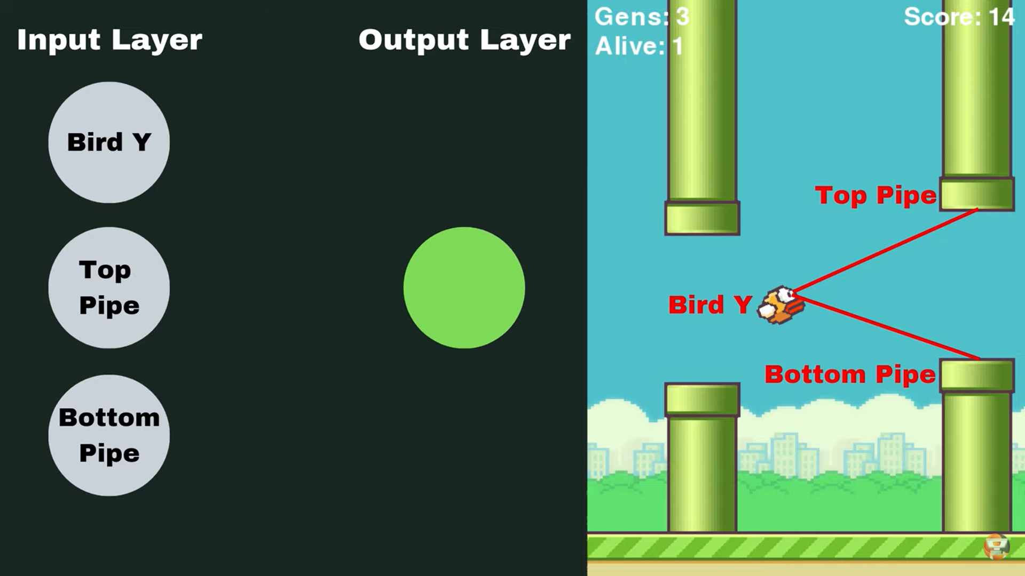

*Image 1: The input layer*

In the Image 1 we can see three pieces of information would be valuable is the position of the bird.

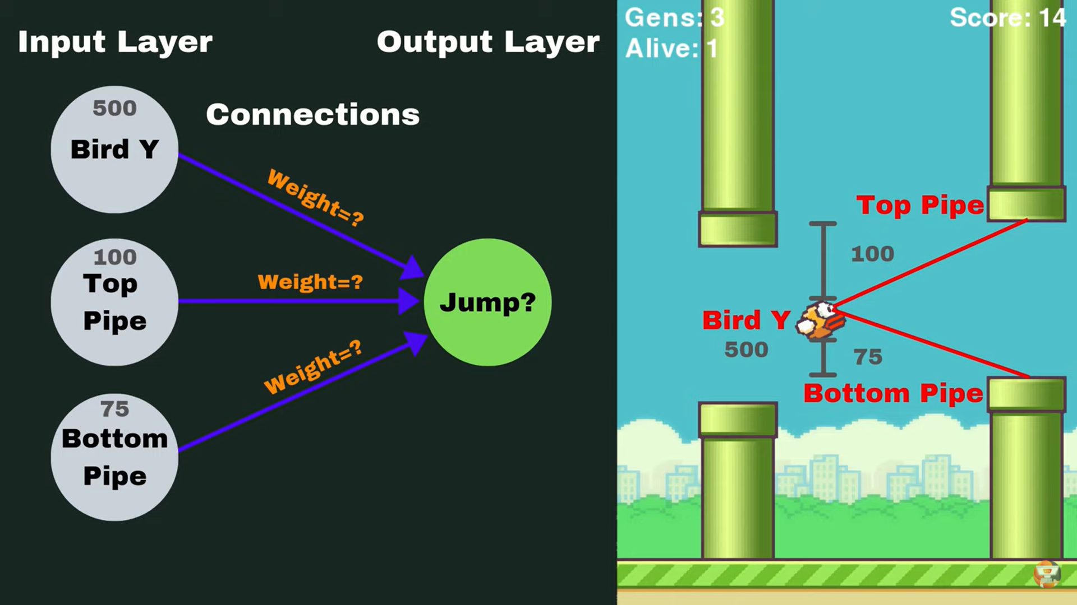

*Image 2: AI get information to decide jump or not*

In the image 2, based on what information we input AI have the idea where the next pipes are coming and make decision to jump or not (output).

**Neuro Evolution of Augmenting Topologies (NEAT)**

We have no idea what the correct number for the weights our bird should be there's no way to kind of figure that out without doing tons of different tests

We don't know so we'll start by creating a population of birds and this population is going to start off completely random and each population is going to consist of 100 birds

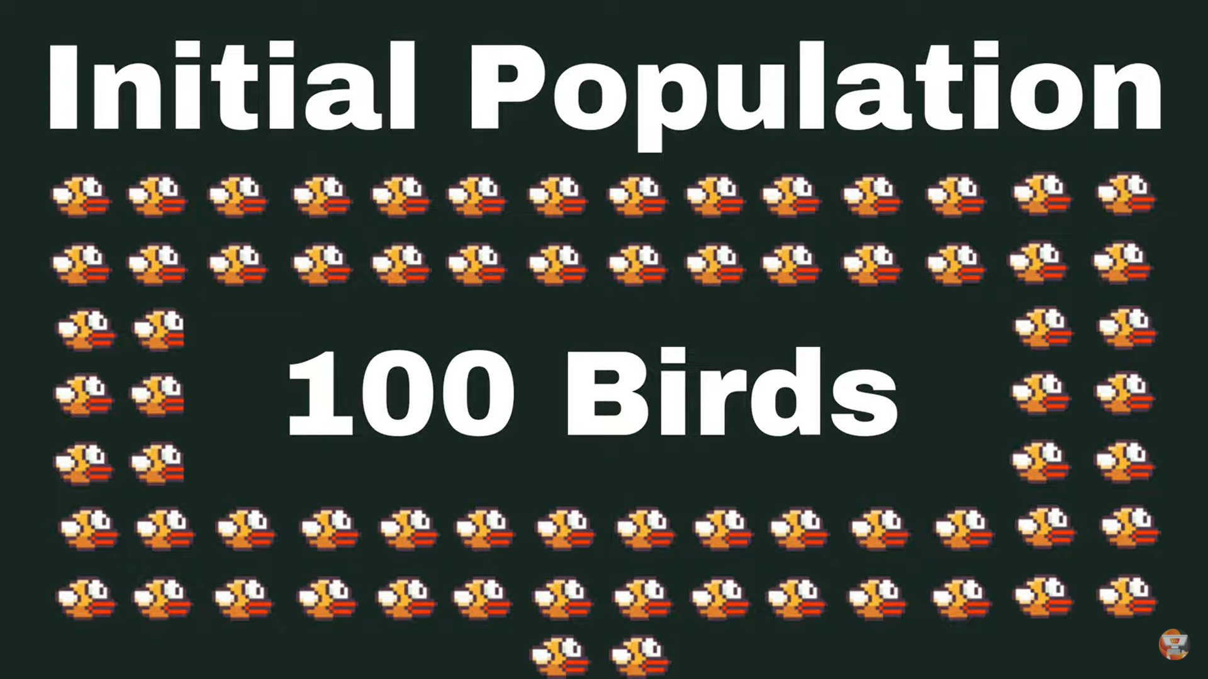

*Image 3: Initial population*

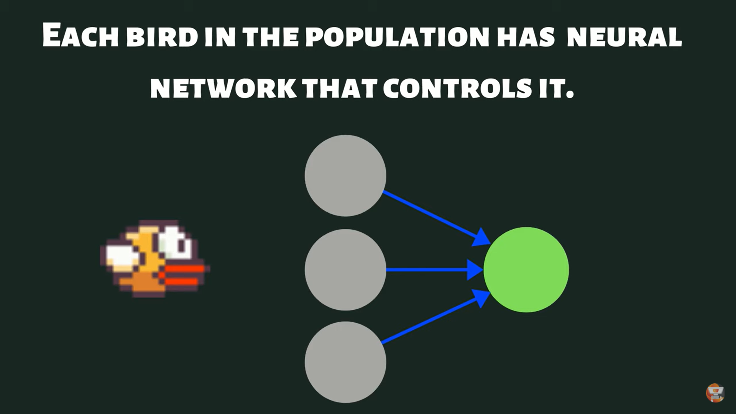

*Image 4: Bird has neural network*

And a neural network that controls that bird now this neural network is going to start with random weights and random biases

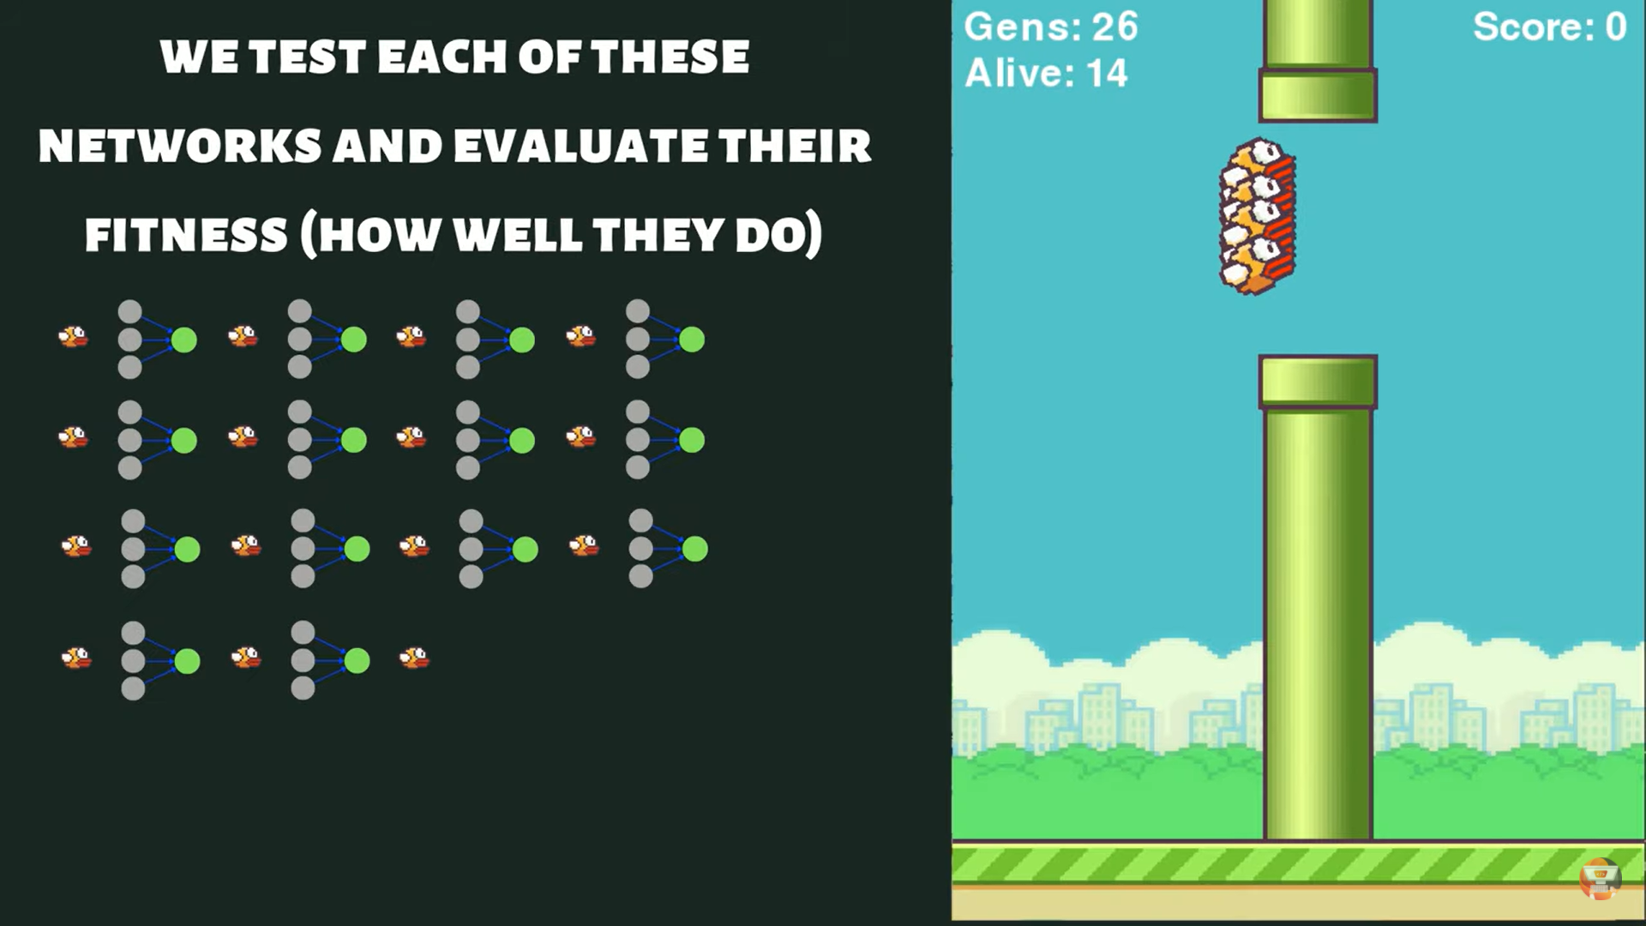

*Image 5: Test all networks*

We're going to test all of these neural networks on our level or on our game and see how well they do we're going to evaluate what we call their fitness now fitness is different depending on what game you're playing

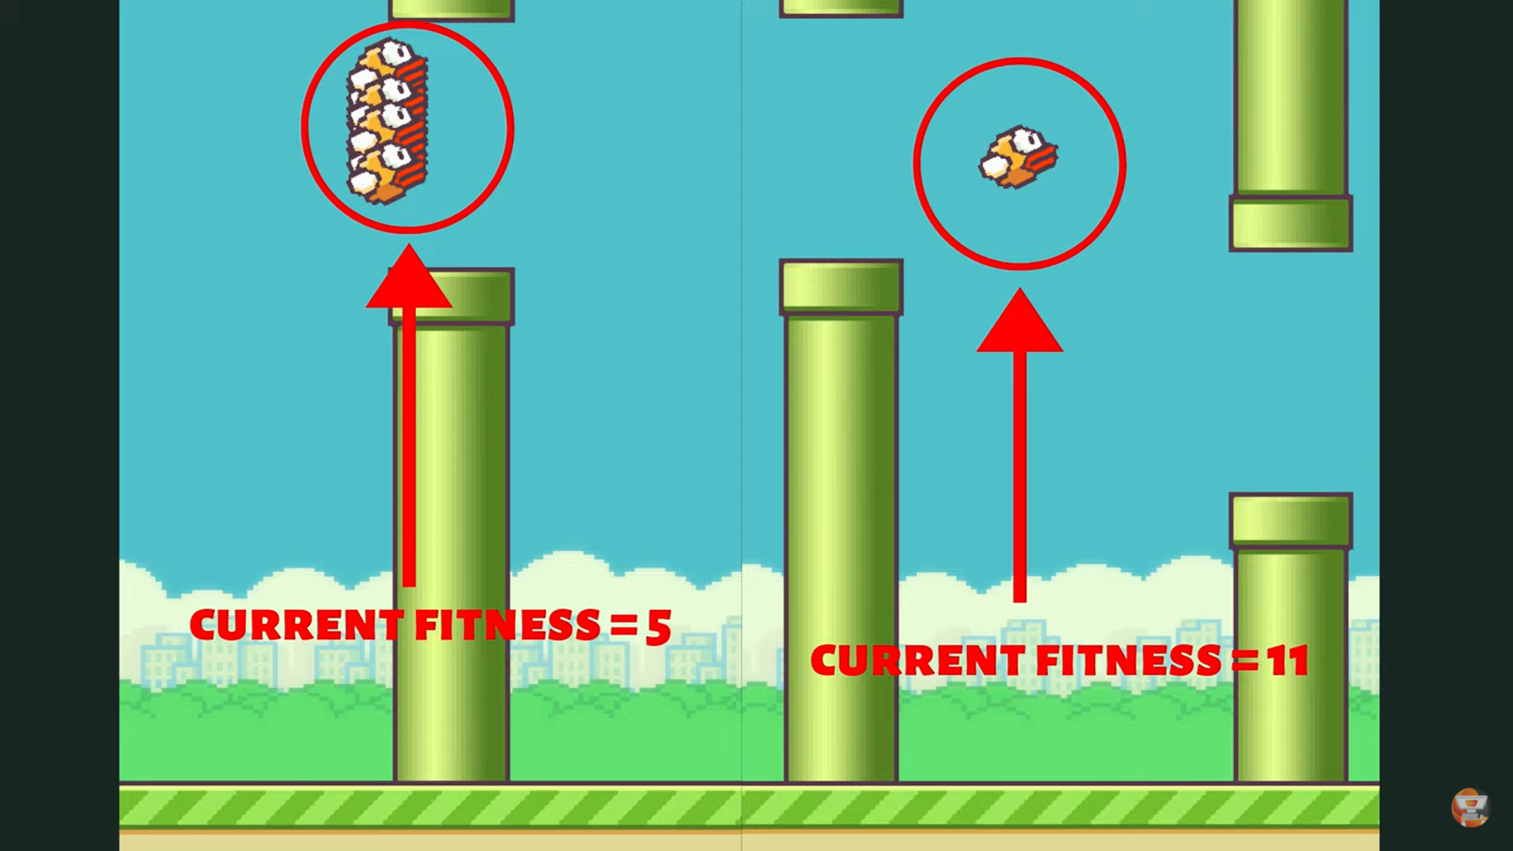

*Image 6: Current fitness*

Every frame it moves forward without dying or without losing it gets another point and that's going to be its fitness score

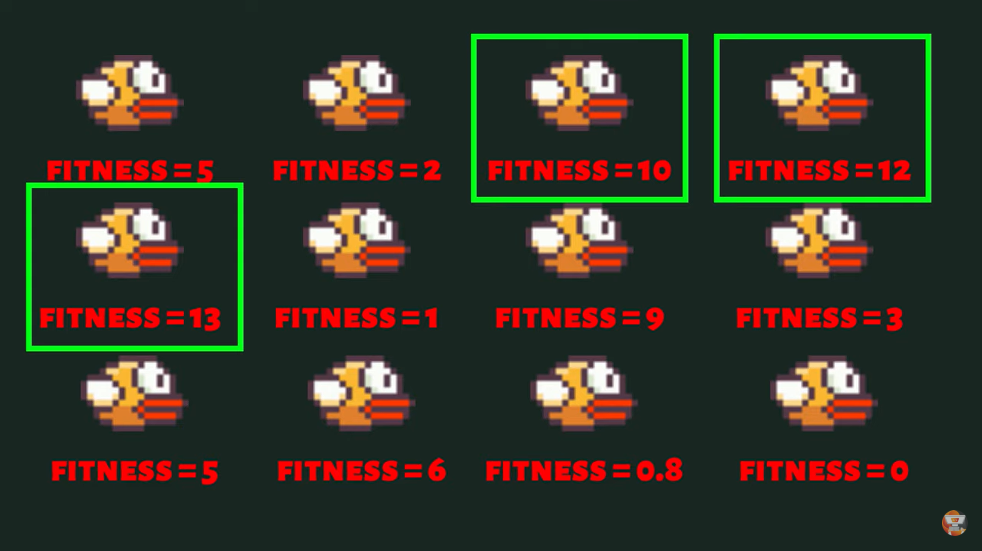

*Image 7: Choose the best*

At the end of the simulation when all our birds have died, we're going to see which one's performed the best in this set of population we're going to take those birds a certain percentage of them

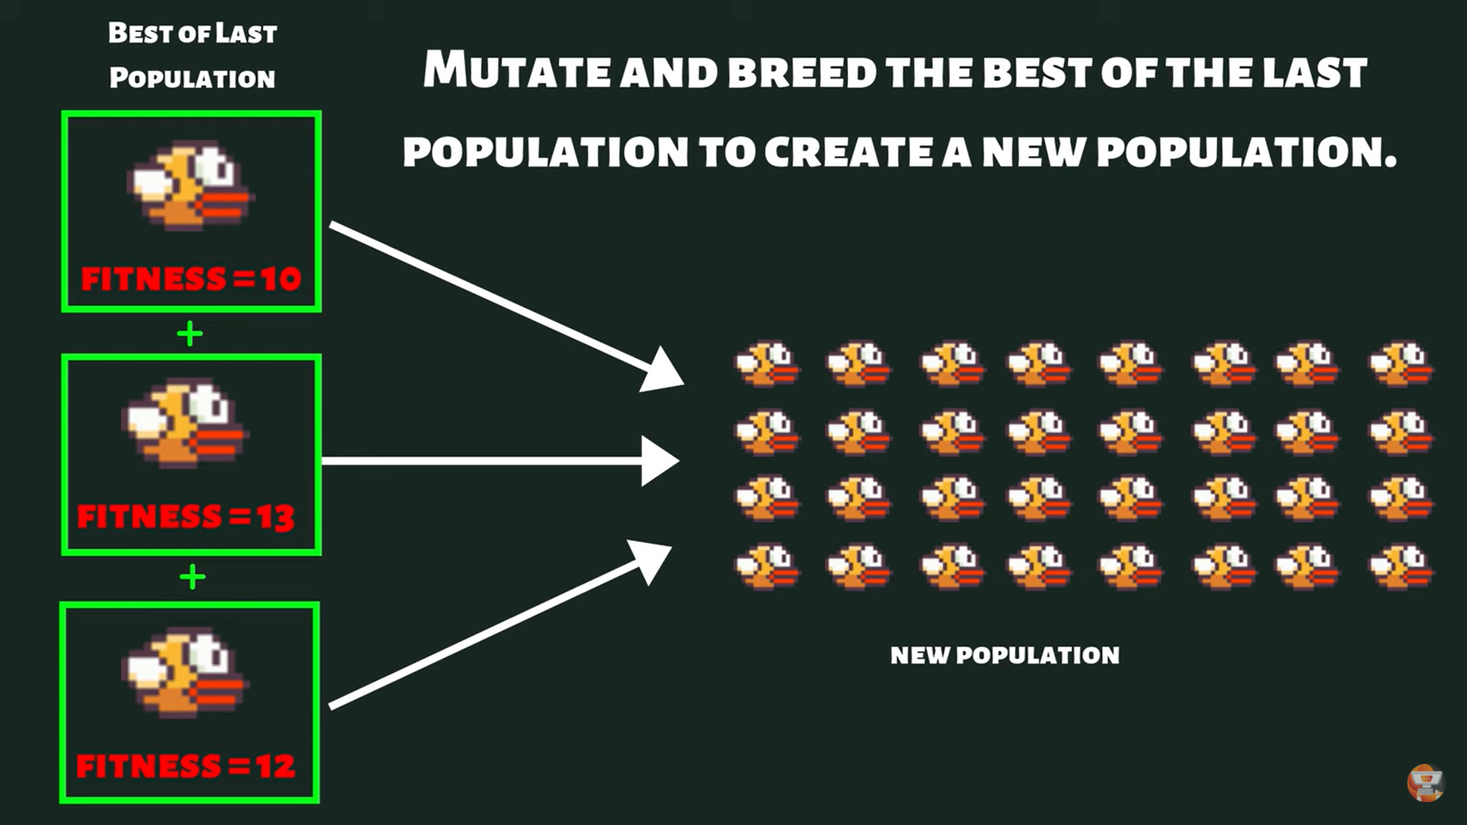

*Image 8: Create new population*

We're going to breed them and mutate them to create a brand new population of a hundred new birds and we're going to get rid of all of the other birds that did poorly so now what we have is we have some offspring from the best birds from the last generation and we hope that these birds are going to perform better than the previous generation because they come from the best of that previous generation

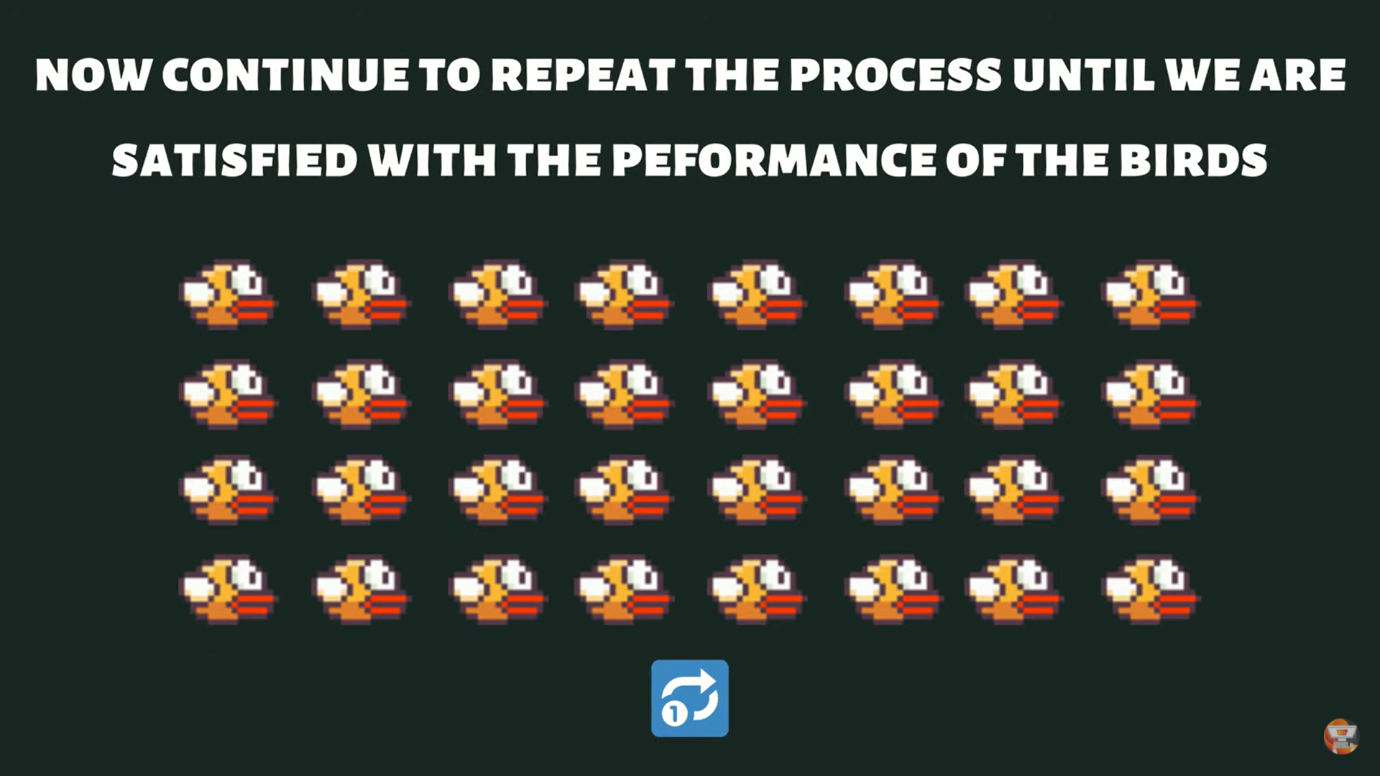

*Image 9: Continue to repeat the process*

And we continue to repeat the process until we are satisfied with the performance of the birds

# Steps:

Step 1: Install environment python 3 and pygame

Step 2: Creating the bird

Step 3: Moving the bird

Step 4: Pixel perfect collision with Pygame

Step 5: Finish the graphics

Step 6: Implement NEAT/ creating a fitness Function

Step 7: Finish touches

# Conclusion:

We learn about how NEAT work and apply it into a real project. The most difficulty is that we must know when, where and how to apply NEAT to train the bird avoid pipe after it die a several time.

Luckily, we finish the project in time, and it work very well. In our Flappy Bird game, the bird can get up to 1000 scored after 1 hours.

We all interesting on Machine Learning and its applications on real life after this project. We give Mr. Bao many thanks for inspire in this subject.